**WEEK #4-5**

**1# Create the tables described below:**

**CREATE DATABASE Master1;**

**USE Master1;**

**CREATE TABLE CLIENT_MASTER (**

**Column_No VARCHAR(30),**

**Data_Type VARCHAR(30),**

**Size INT ,**

**Default_1 VARCHAR(30),**

**Attributes VARCHAR(30));**

**SELECT * FROM CLIENT_MASTER;**

**INSERT INTO CLIENT_MASTER**

**VALUES**

**("CLIENTNO" ,"Varchar2", 6,NULL,NULL),**

**("NAME" ,"Varchar2" ,20,NULL,NULL),**

**("ADDRESS 1", "Varchar2", 30,NULL,NULL),**

**("ADDRESS 2", "Varchar2", 30,NULL,NULL),**

**("CITY" ,"Varchar2" ,15,NULL,NULL),**

**("PINCODE", "Number", 8,NULL,NULL),**

**("STATE","Varchar2", 15,NULL,NULL),**

**("BALDUE", "Number", 10.2,NULL,NULL); OUTPUT:**

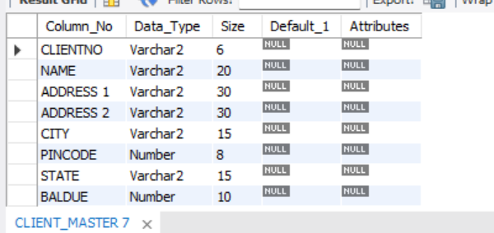

**CREATE TABLE Product_masters(**

**Column_No VARCHAR(30),**

**Data_Type VARCHAR(30),**

**Size INT,**

**Default_1 VARCHAR(30),**

**Attributes VARCHAR(30));**

**INSERT INTO Product_masters**

**VALUES**

**("PRODUCTNO","Varchar2", 6,NULL,NULL),**

**("DESCRIPTION", "Varchar2", 15,NULL,NULL),**

**("PROFITPERCENT","Number",4.2,NULL,NULL),**

**("UNITMEASURE", "Varchar2", 10,NULL,NULL),**

**("QTYONHAND" ,"Number" ,8,NULL,NULL),**

**("REORDERLVL", "Number", 8,NULL,NULL),**

**("SELLPRICE", "Number" ,8.2,NULL,NULL),**

**("COSTPRICE", "Number", 8.2,NULL,NULL);**

**SELECT * FROM Product_masters;**

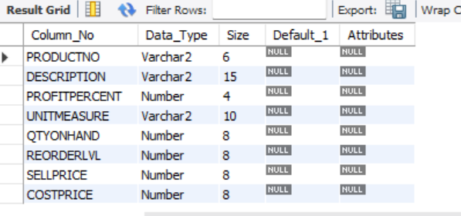

**WEEK #5-6**

**CREATE TABLE CLIENT_MASTER1 (**

**Client_No VARCHAR(30),**

**Name VARCHAR(50),**

**City VARCHAR(30),**

**PINCODE INT ,**

**STATE VARCHAR(30),**

**BALDUE INT);**

**INSERT INTO CLIENT_MASTER1**

**VALUES**

**("C00001", "Ivan Bayross", "Mumbai", 400054 ,"Maharashtra", 15000),**

**("C00002","Mamta Muzumder","Madras", 780001," Tamil Nadu", 0),**

**("C00003", "Chhaya Bankar", "Mumbai", 400057 ,"Maharashtra", 5000),**

**("C00004", "Ashwini Joshi", "Bangalore", 560001 ,"Karnataka", 0),**

**("C00005", "Hansel Colaco", "Mumbai", 400060 ,"Maharashtra", 2000),**

**("C00006", "Deepak Sharma", "Mangalore", 560050 ,"Karnataka",0);**

**-- a) Find out the names of all the clients.**

**SELECT Name FROM CLIENT_MASTER1;**

**-- b) Retrieve the entire contents of the Client_Master table.**

**SELECT * FROM CLIENT_MASTER1;**

**-- c) Retrieve the list of names, city and the state of all the clienT**

**SELECT Name,City,State FROM CLIENT_MASTER1;**

**-- Delete from Client_Master where the column state holds the value 'Tamil Nadu'.**

**DELETE FROM**

**CLIENT_MASTER1**

**WHERE State = "Tamil Nadu";**

**ALTER TABLE CLIENT_MASTER1**

**ADD COLUMN Telephone INT;**

**SET sql_safe_updates = 0;**

**-- Change the city of ClientNo' C00005' to 'Bangalore'.**

**UPDATE CLIENT_MASTER1**

**SET City ="Bangalore"**

**WHERE Client_No = "C00005";**

**-- b) Change the BalDue of ClientNo ‘C00001’ to Rs. 1000**

**UPDATE CLIENT_MASTER1**

**SET BALDUE = 1000**

**WHERE Client_No = "C00005";**

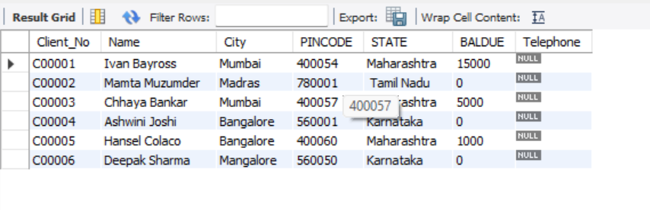

**CREATE TABLE PRODUCT_MASTER1 (**

**Product_No VARCHAR(30),**

**Description VARCHAR(50),**

**Profit_Percent INT,**

**Unit_Measure VARCHAR(30),**

**Qty_On_Hand INT ,**

**Reorder_lvl INT,**

**Sell_Price INT,**

**Cost_Price INT);**

**INSERT INTO PRODUCT_MASTER1**

**VALUES**

**("P00001", "T-Shirts", 5 ,"Piece" ,200 ,50 ,350 ,250),**

**("P0345", "Shirts", 6, "Piece", 150, 50, 500, 350),**

**("P06734" ,"Cotton Jeans" ,5 ,"Piece" ,100 ,20 ,600 ,450),**

**("P07865", "Jeans", 5 ,"Piece", 100, 20, 750, 500),**

**("P07868", "Trousers" ,2, "Piece" ,150 ,50 ,850 ,550),**

**("P07885", "Pull Overs", 2.5, "Piece", 80, 30, 700, 450),**

**("P07965", "Denim Shirts", 4, "Piece", 100, 40, 350, 250),**

**("P07975", "Lycra Tops", 5 ,"Piece", 70, 30, 300, 175),**

**("P08865", "Skirts", 5, "Piece", 75, 30, 450, 300);**

**-- c) Change the cost price of 'Trousers' to Rs. 950.00**

**UPDATE PRODUCT_MASTER1**

**SET Cost_Price = 950**

**WHERE Description = 'Trousers';**

**-- Delete all products from Product_Master where the quantity on hand**

**-- is equal to 100.**

**DELETE FROM PRODUCT_MASTER1**

**WHERE Qty_On_Hand = 100;**

**-- Change the size of SellPrice column in Product_Master to 10,2**

**ALTER TABLE PRODUCT_MASTER1**

**MODIFY Sell_Price DECIMAL(10.2);**

**SELECT * FROM PRODUCT_MASTER1;**

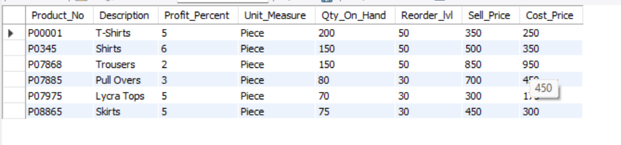

**CREATE TABLE SALESMAN_MASTER1(**

**SalesMan_No VARCHAR(30),**

**Name VARCHAR(30),**

**Address_1 VARCHAR(30),**

**Address_2 VARCHAR(30),**

**City VARCHAR(30),**

**PinCode INT,**

**STATE VARCHAR(30),**

**SALAMT INT);**

**INSERT INTO SALESMAN_MASTER1**

**VALUES**

**("S00001", "Aman", "A/14", "Worli", "Mumbai", 400002, "Maharashtra", 3500),**

**("S00002", "Omkar", "65", "Nariman", "Mumbai", 400001 ,"Maharashtra" ,4000),**

**("S00003", "Raj", "P-7", "Bandra", "Mumbai", 400032 ,"Maharashtra", 5000),**

**("S00004","Ashish" ,"A/5" ,"Juhu", "Mumbai" ,400044 ,"Maharashtra", 3500);**

**SELECT * FROM SALESMAN_MASTER1 ;**

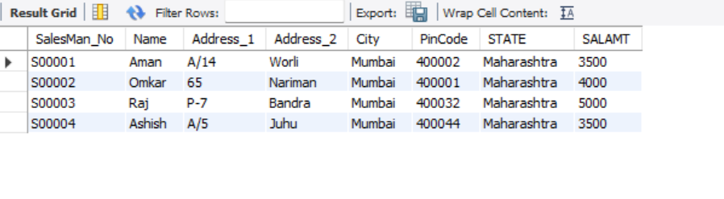

**-- Delete all salesman from the Salesman_Master whose salaries are**

**-- equal to Rs. 3500**

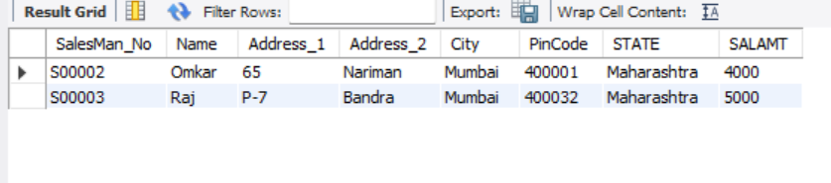

**DELETE FROM SALESMAN_MASTER1**

**WHERE SALAMT = 3500;**

**-- Change the name of the Salesman_Master table to sman_mast**

**ALTER TABLE SALESMAN_MASTER1**

**RENAME TO Sman_mast;**